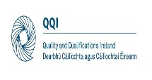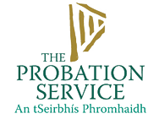

**Adult Education Service**

**Referral Form 2024**

This form is designed to collect information required by providers and funders to refer clients for registration on the bridge projects BTEI and CE programme.

**Preferred form of contact Please tick √:** Letter: email: Phone:

|  |
| --- |
| **Course Title: Back to Education and Training Initiative, or CE Scheme**  **Venue: The Bridge Project 131 – 133 Francis Street, Dublin 8.** |
| **Section 1: Clients Personal Details: Please Complete in Block Capital Letters** |
| First Name: Phone:  Family Name: Mobile:  Address: Date of birth:  Age:  PPS:  Email: CE Place:  BTEI Place:  Hair & Beauty  Barbering  Barista  Please tick ✓ |

|  |  |
| --- | --- |
| **Referred by – Name of referring organisation:**  **Probation Client: Yes No Details:** | |
| **Referral Organisation Contact Details:** |  |
| **Tel:** |  |
| **Offending Details:** |  |
| **Substance Use Details:** |  |
| **Mental Health Issues:** |  |
| **Education/ Learning Issues:** |  |
| **Additional Comments:** |  |
| **Previous Group Work Experience:** |  |

Signed by referrer: Date:

**All correspondence should be addressed to the Education Coordinator at Bridge,** [**sorcha@bridge.ie**](mailto:sorcha@bridge.ie)